Updating Remote Storage Item Records

Prepared by Adam Baron

# Introduction

When items from most Remote Storage locations are checked in, the status is not changed to IN TRANSIT. Instead, the IMESSAGE **x REMOTE STORAGE ITEM** is used to notify staff in Access Services that that item needs to be sent to Remote Storage.

*Exceptions:*

When items with the Remote Storage locations **xmed Media Remote Storage** and **xmus Music Remote Storage** are checked in, the status is changed to IN TRANSIT. To clear the IN TRANSIT status before returning the items to Remote Storage, items with the location **xmed Media Remote Storage** must be routed through the Media Library and items with the location **xmus Remote Storage** must be routed through the Music Library. To provide clear instructions to staff in Access Services, these locations use both the IMESSAGE fixed-length field and the m-tagged variable-length message field.

# General Procedure

1. In Create Lists, use the sample queries provided to create review files of item records that may need to be updated.
2. As some of the provided queries will retrieve records that do not need to be updated, use Global Update to inspect results, remove records that do not need updating, and correct errors.
3. In Global Update, update the IMESSAGE fixed field and, if applicable, the variable message field.

|  |  |  |
| --- | --- | --- |
| Item Location | IMESSAGE | Message (variable-length) |
| x Remote Storage | x REMOTE STORAGE ITEM |  |
| xdoc Government Documents Remote Storage | x REMOTE STORAGE ITEM |  |
| xmed Media Remote Storage | c MEDIA REMOTE STORAGE ITEM | Send Media Remote Storage Item to Media Library |
| xmic Remote Storage Microforms | x REMOTE STORAGE ITEM |  |
| xmus Music Remote Storage | m MUSIC REMOTE STORAGE ITEM | Send Music Remote Storage Item to Music Library |
| xspe Special Collections Remote Storage | x REMOTE STORAGE ITEM |  |

# New Items in Remote Storage

## General Collections

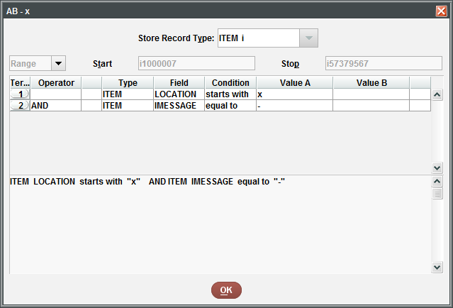

* Remove the following locations:
  + xmed Media Remote Storage
  + xmus Music Remote Storage
  + xprsv PRESERVATION LAB
  + xts Collection Management Work Room
* Verify the following fields:
  + Message: Generally, do not use to indicate Remote Storage
  + IMESSAGE: - NO MESSAGE
* Change IMESSAGE to: x REMOTE STORAGE ITEM

## Media Remote Storage

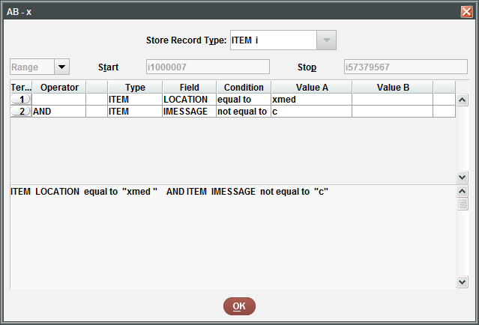

* Verify the following fields:
  + Location: xmed Media Remote Storage
  + IMESSAGE: Most likely, - NO MESSAGE
  + Message: Possibly delete if contains “remote storage”
* Change IMESSAGE to: c MEDIA REMOTE STORAGE ITEM
* Add message: Send Media Remote Storage Item to Media Library

## Music Remote Storage

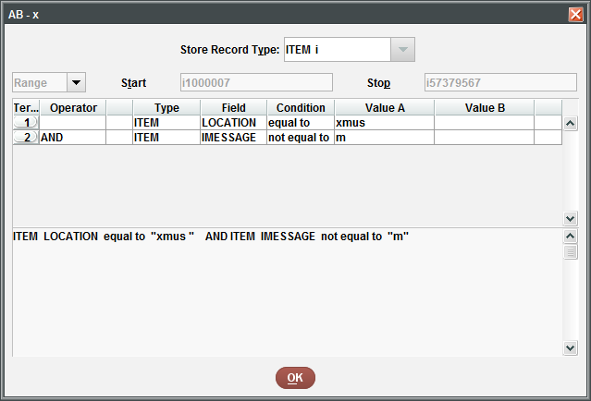

* Verify the following fields:
  + Location: xmus Music Remote Storage
  + IMESSAGE: Most likely, - NO MESSAGE
  + Message: Possibly delete if contains “remote storage”
* Change IMESSAGE to: m MUSIC REMOTE STORAGE ITEM
* Add message: Send Music Remote Storage Item to Music Library

# Items No Longer in Remote Storage

## General Collections

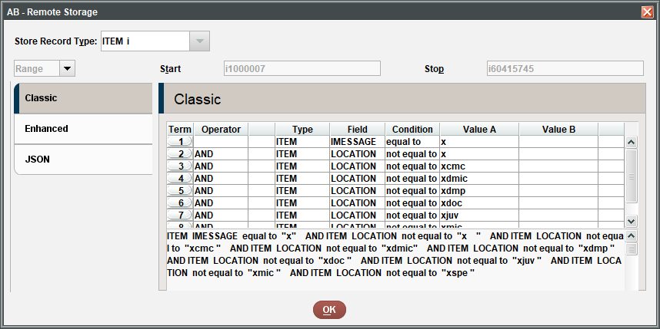

See JSON query at end of document.

* Verify the following fields:
  + Location: Should not be any Remote Storage Location
  + IMESSAGE: x REMOTE STORAGE ITEM
  + Message: Should not be used to indicate Remote Storage
* Change IMESSAGE to: - NO MESSAGE

## Media Remote Storage

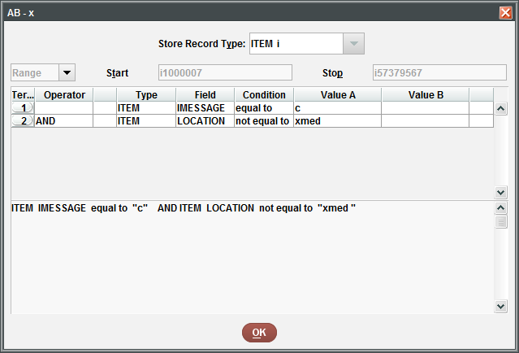

* Verify the following fields:
  + Location: Anything except xmed Media Remote Storage
  + IMESSAGE: c MEDIA REMOTE STORAGE ITEM
  + Message: Send Media Remote Storage Item to Media Library
* Change IMESSAGE to: - NO MESSAGE
* Delete message: Send Media Remote Storage Item to Media Library

## Music Remote Storage

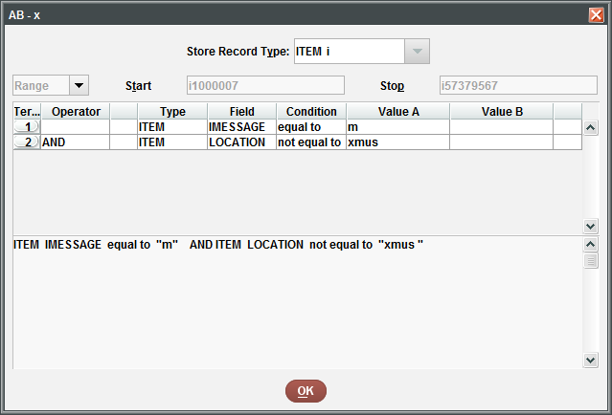

* Verify the following fields:
  + Location: Anything except xmus Music Remote Storage
  + IMESSAGE: m MUSIC REMOTE STORAGE ITEM
  + Message: Send Music Remote Storage Item to Music Library
* Change IMESSAGE to: - NO MESSAGE
* Delete message: Send Music Remote Storage Item to Music Library

## Remote Storage Message

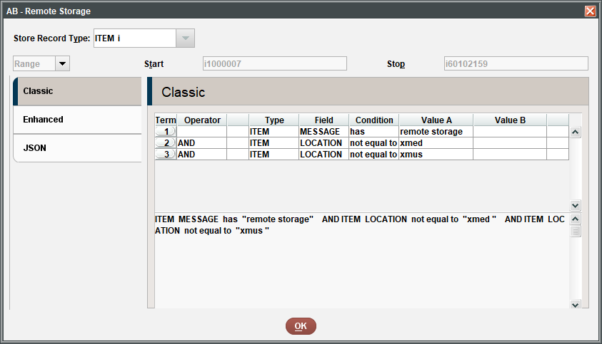

* Verify the following fields:
  + Location: Should not be any Media Remote Storage or Music Remote Storage
  + IMESSAGE: Should be – NO MESSAGE or x REMOTE STORAGE ITEM
  + Message: Should not be used to indicate Remote Storage
* Investigate if is not - NO MESSAGE
* Delete message if indicates item is in Remote Storage

## Alternative Query: Remote Storage Message

### 

* Verify the following fields:
  + Location: Should not be any Remote Storage Location
  + IMESSAGE: Should be – NO MESSAGE
  + Message: Should not be used to indicate Remote Storage
* Change IMESSAGE to: - NO MESSAGE
* Delete message if indicates item is in Remote Storage

# JSON Query for General Collection No Longer in Remote Storage

{

"queries": [

{

"target": {

"record": {

"type": "item"

},

"id": 97

},

"expr": {

"op": "equals",

"operands": [

"x",

""

]

}

},

"and",

{

"target": {

"record": {

"type": "item"

},

"id": 79

},

"expr": {

"op": "not_equal",

"operands": [

"x ",

""

]

}

},

"and",

{

"target": {

"record": {

"type": "item"

},

"id": 79

},

"expr": {

"op": "not_equal",

"operands": [

"xcmc ",

""

]

}

},

"and",

{

"target": {

"record": {

"type": "item"

},

"id": 79

},

"expr": {

"op": "not_equal",

"operands": [

"xdmic",

""

]

}

},

"and",

{

"target": {

"record": {

"type": "item"

},

"id": 79

},

"expr": {

"op": "not_equal",

"operands": [

"xdmp ",

""

]

}

},

"and",

{

"target": {

"record": {

"type": "item"

},

"id": 79

},

"expr": {

"op": "not_equal",

"operands": [

"xdoc ",

""

]

}

},

"and",

{

"target": {

"record": {

"type": "item"

},

"id": 79

},

"expr": {

"op": "not_equal",

"operands": [

"xjuv ",

""

]

}

},

"and",

{

"target": {

"record": {

"type": "item"

},

"id": 79

},

"expr": {

"op": "not_equal",

"operands": [

"xmic ",

""

]

}

},

"and",

{

"target": {

"record": {

"type": "item"

},

"id": 79

},

"expr": {

"op": "not_equal",

"operands": [

"xspe ",

""

]

}

}

]

}